**How He Used Facebook to Win**

[**Sue Halpern**](http://www.nybooks.com/contributors/sue-m-halpern/)

[JUNE 8, 2017 ISSUE](http://www.nybooks.com/issues/2017/06/08/)

[***Prototype Politics: Technology-Intensive Campaigning and the Data of Democracy***](http://www.amazon.com/gp/product/0199350256?ie=UTF8&tag=thneyoreofbo-20&linkCode=as2&camp=1789&creative=9325&creativeASIN=0199350256)

by Daniel Kreiss

Oxford University Press, 291 pp., $99.00; $27.95 (paper)

[***Hacking the Electorate: How Campaigns Perceive Voters***](http://www.amazon.com/gp/product/1107102898?ie=UTF8&tag=thneyoreofbo-20&linkCode=as2&camp=1789&creative=9325&creativeASIN=1107102898)

by Eitan D. Hersh

Cambridge University Press, 261 pp., $80.00; $30.99 (paper)

[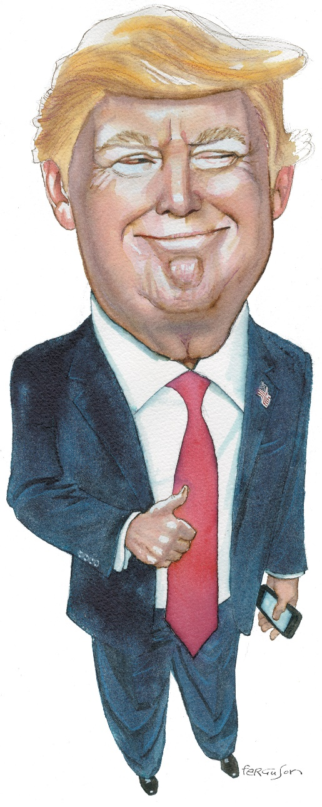](https://shop.nybooks.com/products/donald-trump-2022)Donald Trump; drawing by James Ferguson

Not long after Donald Trump’s surprising presidential victory, an article published in the Swiss weekly *Das Magazin*, and reprinted online in English by *Vice*, began churning through the Internet. While pundits were dissecting the collapse of Hillary Clinton’s campaign, the journalists for *Das Magazin*, Hannes Grassegger and Mikael Krogerus, pointed to an entirely different explanation—the work of Cambridge Analytica, a data science firm created by a British company with deep ties to the British and American defense industries.

According to Grassegger and Krogerus, Cambridge Analytica had used psychological data culled from Facebook, paired with vast amounts of consumer information purchased from data-mining companies, to develop algorithms that were supposedly able to identify the psychological makeup of every voter in the American electorate. The company then developed political messages tailored to appeal to the emotions of each one. As the *New York Times* reporters Nicholas Confessore and Danny Hakim described it:

A voter deemed neurotic might be shown a gun-rights commercial featuring burglars breaking into a home, rather than a defense of the Second Amendment; political ads warning of the dangers posed by the Islamic State could be targeted directly at voters prone to anxiety….

Even more troubling was the underhanded way in which Cambridge Analytica appeared to have obtained its information. Using an Amazon site called Mechanical Turk, the company paid one hundred thousand people in the United States a dollar or two to fill out an online survey. But in order to receive payment, those people were also required to download an app that gave Cambridge Analytica access to the profiles of their unwitting Facebook friends. These profiles included their Facebook “likes” and their own contact lists.

According to the investigative reporter Mattathias Schwartz, writing in *The Intercept*, a further 185,000 people were recruited from an unnamed data company, to gain access to another 30 million Facebook profiles. Again, none of these 30 million people knew their data were being harvested and analyzed for the benefit of an American political campaign.

Facebook did turn out to be essential to Trump’s victory, but not in the way Grassegger, Krogerus, and Schwartz suggest. Though there is little doubt that Cambridge Analytica exploited members of the social network, Facebook’s real influence came from the campaign’s strategic and perfectly legal use of Facebook’s suite of marketing tools. (It should be noted that internal Facebook documents leaked in early May show that Facebook itself has been mining users’ emotional states and sharing that information with advertisers.)

After the initial alarm that an obscure data firm might have wormed its way into the American psyche deeply enough to deliver the election to Trump, critics began to question what Alexander Nix, the head of Cambridge Analytica, called the firm’s “secret sauce,” the algorithms it used to predict a voter’s psychological profile, what is known as “psychographics.” Confessore and Hakim’s article about the firm, which appeared on the front page of the *Times*, quoted numerous consultants, working for both parties, who were dismissive of the firm’s claims. The mathematician Cathy O’Neil, in a commentary for *Bloomberg*, called Cambridge Analytica’s secret sauce “just more ketchup.” Using psychological traits to craft appeals to voters, she wrote, wasn’t anything new—every candidate was doing it.

For decades, in fact, campaigns have been using and refining “microtargeting” techniques, looking at religious affiliations, buying habits, demographic traits, voting histories, educational attainment, magazine subscriptions, and the like, parsing the electorate in order to understand which values and issues are driving which voters. For a few election cycles starting at the turn of the century, the Republicans had the advantage, developing a database called Voter Vault that allowed party operatives to understand voters in an increasingly nuanced way. During the 2004 presidential campaign, for example, the Bush team surveyed a large sample of these voters to assess their attitudes and behaviors, and sorted them into thirty groups, each with similar interests, lifestyles, ideologies, and affinities. It then placed every other voter into one of these groups and developed messaging intended to appeal to each one.

By 2008, however, the microtargeting advantage had shifted to the Democrats, who had developed their own enormous, dissectable database of voters called VoteBuilder, run by the Democratic National Committee, and others run by for-profit companies that had been created to support the party’s candidates. One of these, Catalist, boasts a national database of 240 million people of voting age, with information on each one drawn from voting rolls, the census, and other public records, as well as commercial data covering “hundreds of fields, including household attributes, purchasing and investment profiles, donation behavior, occupational information, recreational interests, and engagement with civic and community groups.” In 2008 and 2012, the Democrats also had more sophisticated models predicting how people with certain attributes might vote.

In the course of the 2016 election, the Trump campaign ended up relying on three voter databases:

1. the one supplied by Cambridge Analytica, with its 5,000 data points on 220 million Americans including, according to its website, personality profiles on all of them;
2. the RNC’s enhanced Voter Vault, which claims to have more than 300 terabytes of data, including 7,700,545,385 microtargeting data points on nearly 200 million voters; and
3. its own custom-designed one, called Project Alamo, culled in part from the millions of small donors to the campaign and e-mail addresses gathered at rallies, from sales of campaign merchandise, and even from text messages sent to the campaign. Eventually, Project Alamo also came to include data from the other two databases.

A principal force behind these various strategies was Brad Parscale, who served as the digital director of the Trump campaign from the primaries through the general election and who in the late spring of 2016 hired Cambridge Analytica as part of this effort. Parscale, who works out of San Antonio, had designed websites for Trump Wineries and other Trump enterprises. Through that work he became friends with Eric Trump, Donald Trump’s son, and Jared Kushner, Trump’s son-in-law and adviser, who Parscale says is like a brother to him.

Further binding these family ties, Parscale’s marketing and design firm, Giles-Parscale, recently hired Eric Trump’s wife, Lara, to work on Donald Trump’s 2020 reelection campaign. “My loyalty is to the family,” Parscale told the journalists Joshua Green and Sasha Issenberg, whose *Bloomberg* article “Inside the Trump Bunker, with Days to Go,” on the campaign’s digital strategy, turned out to be the most prescient piece written about Trump’s stunning upset.

In the early phase of the primaries, Parscale launched Trump’s digital operation by buying $2 million in Facebook ads—his entire budget at the time. He then uploaded all known Trump supporters into the Facebook advertising platform and, using a Facebook tool called Custom Audiences from Customer Lists, matched actual supporters with their virtual doppelgangers and then, using another Facebook tool, parsed them by race, ethnicity, gender, location, and other identities and affinities. From there he used Facebook’s Lookalike Audiences tool to find people with interests and qualities similar to those of his original cohort and developed ads based on those characteristics, which he tested using Facebook’s Brand Lift surveys. He was just getting started. Eventually, Parscale’s shop was reportedly spending $70 million a month on digital advertising, most of it on Facebook. (Facebook and other online venues also netted Trump at least $250 million in donations.)

While it may not have created individual messages for every voter, the Trump campaign used Facebook’s vast reach, relatively low cost, and rapid turnaround to test tens of thousands and sometimes hundreds of thousands of different campaign ads. According to Issie Lapowsky of *Wired*, speaking with Gary Coby, director of advertising at the Republican National Committee and a member of Trump’s digital team:

On any given day…the campaign was running 40,000 to 50,000 variants of its ads, testing how they performed in different formats, with subtitles and without, and static versus video, among other small differences. On the day of the third presidential debate in October, the team ran 175,000 variations. Coby calls this approach “A/B testing on steroids.”

And this was just Facebook. The campaign also placed ads on other social media, including Twitter and Snapchat, and ran sponsored content on *Politico*. According to one estimate by a campaign insider, the Trump team spent “in the high eight figures just on persuasion.” Remarkably, none of this money was used on ads created from Cambridge Analytica’s questionably obtained Facebook data.

Not long after touting the edge it gave the Trump campaign, Cambridge Analytica began walking back its initial claim that psychological targeting was crucial to Trump’s victory. “I don’t want to break your heart; we actually didn’t do any psychographics with the Trump campaign,” Matt Oczkowski, Cambridge Analytica’s chief data scientist, told a panel hosted by Google five weeks after the election. Because the firm was only brought onto the Trump campaign the summer before the general election, he said, “we had five months to scale extremely fast, and doing sexy psychographics profiles requires a much longer run time.” Apparently, Cambridge Analytica had deployed its psychological targeting techniques during the Republican primaries on behalf of Ted Cruz, but Cruz’s failure to win the nomination was cited as evidence that Cambridge Analytica’s models were ineffective and that the company did not understand American politics.

Though Cambridge Analytica came late to American elections, its British parent company, Strategic Communications Laboratories (SCL), has been a client of the United States government for years. SCL has “provided intelligence assessments for American defense contractors in Iran, Libya and Syria,” according to the *Times*, and developed so-called influence campaigns for NATO in Afghanistan. Also in Afghanistan, SCL engaged in “target audience analysis” for the United States Department of Defense, identifying who was susceptible to American propaganda. The firm’s methodology, according to its website, has been approved by the UK Ministry of Defence, the US State Department, Sandia National Laboratories, and NATO. It seeks “to understand empirically what the right levers or ‘triggers and filters’ in a given population are, based on a penetrating psychological understanding.” SCL is currently seeking contracts with at least a dozen US agencies, and *The Washington Post* recently reported that it has already secured work with the State Department.

Strategic Communications Laboratories may have a special advantage in these efforts now that Cambridge Analytica is largely controlled by Robert Mercer, one of Trump’s major donors. According to *The Guardian*, Mercer now owns 90 percent of the company, with SCL owning the remaining 10 percent. (Mercer is also the money behind Breitbart News, the website credited with serving up fake and hyped-up articles to incite Trump’s base.) Steve Bannon, Trump’s chief strategist and the former executive chairman of Breitbart News, was on the Cambridge Analytica board until he became the Trump campaign’s chief executive. Robert Mercer’s daughter, Rebekah, served on Trump’s transition team and has stayed on as a Trump adviser. She now runs Making America Great, a pro-Trump advocacy organization largely funded by her father that is dedicated to creating influence campaigns to push what has been called a nationalist—anti-immigration, anti-government—agenda. Its day-to-day director is Emily Cornell, who stepped down as Cambridge Analytica’s senior vice-president for political affairs to take the position.

[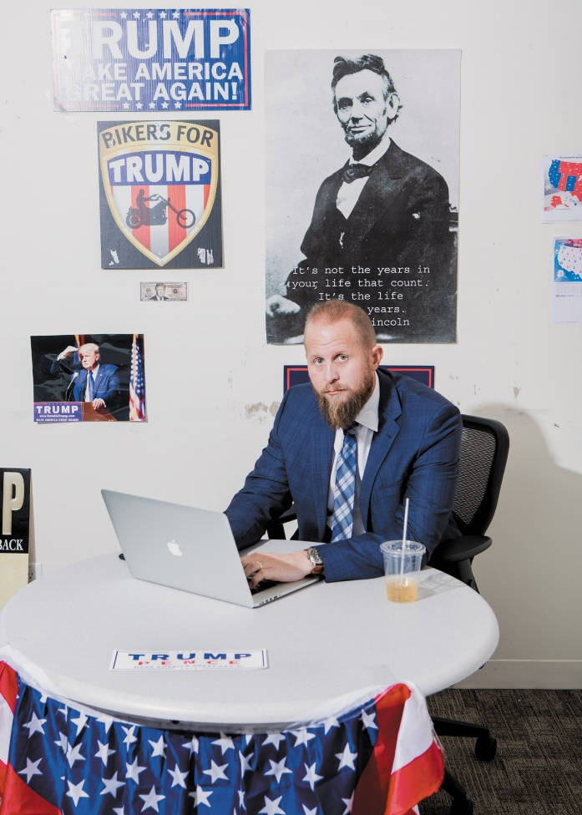](http://www.nybooks.com/wp-content/uploads/2017/05/halpern_2-060817.jpg)Alex Welsh

Brad Parscale, the Trump campaign’s digital director, Trump Tower, New York City, October 2016

Meanwhile, as SCL pursues government contracts, Cambridge Analytica is also vying to create influence campaigns on behalf of the Trump Organization, the parent company of Trump’s various business interests. As an unnamed conservative digital strategist told *The Guardian*, the data from Cambridge Analytica could be helpful in both “driving sales and driving policy goals. Cambridge is positioned to be the preferred vendor for all that.”

But weeks before the Mercers set up Making America Great, Brad Parscale had already created his own Trump advocacy group, called America First Policies. The creation of two independent organizations both ostensibly aimed at mustering support for Trump appears to have presaged the fault line that is now emerging between

1. Steve Bannon and the Mercers on one side, and
2. Jared Kushner (and by default Giles-Parscale) on the other.

This division was also manifest days after the election as members of team Trump took a victory lap, with Cambridge Analytica’s Nix crediting his firm with the win, and Parscale declaring to the contrary that it was his and Kushner’s overall digital strategy that took Trump over the top.

Either way, that rift pulls back the curtain on contemporary electioneering—electioneering in the age of big data and social media, both of which were crucial to Trump’s victory, and were used in innovative ways that are likely to be adopted by other candidates from both parties. As Daniel Kreiss points out in his book *Prototype Politics*, losing campaigns, especially, look to the winning one “to find models for future action.”

There is no doubt that Trump’s digital operation—overseen by Parscale with the involvement of Giles-Parscale, Cambridge Analytica, the Republican National Committee, and scores of contractors—drew heavily on Barack Obama’s 2012 reelection playbook. Recalling that campaign, Kreiss describes how the Democrats repurposed a marketing strategy called “uplift” or “brand lift” and used it to pursue voters they identified as receptive to Obama’s message. They did so by gathering millions of data points on the electorate from public sources, commercial information brokers, and their own surveys, then polling voters with great frequency and looking for patterns in the responses.

All this was used to create predictive models of who was likely to vote for Obama, who was not, and who was open to persuasion. It also indicated who would be disinclined to vote for Obama if contacted by the campaign. These models sorted individuals into categories—let’s say, mothers concerned about gun violence or millennials with significant college debt—and these categories were used to tailor communications to members of each group. Kreiss observes that such sorting was necessary because it would have been nearly impossible to create personalized messages for individuals from a labor standpoint…. And…the cost of testing individual appeals to determine whether they were actually successful in order to justify the expense of creating them would have been astronomical.

In his 2015 book *Hacking the Electorate*, Eitan Hersh is skeptical about the value of commercial data in predicting political outcomes—his research shows that public records are crucial. Echoing Kreiss, he writes that “even in well-financed campaigns, there is rarely an interest among campaign strategists to send fifty different messages to fifty different segments of voters.” The Trump campaign, with its “A/B testing on steroids,” turned this conventional wisdom on its head.

There were other digital innovations as well. On election day, for example, the Trump campaign bought all the ad space on YouTube and ran a series of five thirty-second videos, each hosted by a different Trump surrogate representing a particular segment of the Trump base. We “learned that putting Mr. Trump on persuasion ads was a bad idea,” Cambridge Analytica’s Oczkowski said in April at a meeting of the Association for Data-Driven Marketing and Advertising in Melbourne, Australia. Instead, there was Ivanka Trump, representing mothers and business women; Willie Robertson, the star of the television show *Duck Dynasty*, to appeal to southerners and hunters; Milwaukee sheriff David Clarke, representing law and order and diversity (he is African-American); the former Navy Seal Marcus Luttrell to appeal to veterans and their families; and Ultimate Fighting Championship president Dana White, a tough, aggressive guy’s guy.

“There was no targeting,” Oczkowski explained. “Every single American who [went] to YouTube that day [saw these ads].” And, he continued, once viewers watched one of the thirty-second videos to the end, they landed on a screen with a polling place locator. “We had tens of millions of people view the videos and hundreds of thousands of people use the ‘find your polling place’ locator. When you’re talking about winning by thousands of votes, this stuff matters,” Oczkowski said.

Parscale’s strategy of using Facebook’s “dark posts” also turned out to matter, enabling the Trump campaign to attack Clinton with targeted negative ads that flew below the public radar. Dark posts are not illegal. They are not necessarily “dark.” Unlike a regular Facebook advertisement, which appears on one’s timeline and can be seen by one’s friends, dark posts are invisible to everyone but the recipient. Facebook promotes them as “unpublished” posts that “allow you to test different creative variations with specific audiences without overloading people on your Page with non-relevant or repetitive messages.”

Phrased this way, dark posts sound benign, even benevolent. Parscale and his crew had other ideas. Facebook dark posts, used in tandem with more traditional attack ads, were part of the Trump team’s concerted effort to dissuade potential Clinton voters from showing up at the polls. (In March, Cambridge Analytica won an Advertising Research Foundation David Ogilvy Award for its “Can’t Run Her House” ad, which used a clip from the 2008 Democratic primary of Michelle Obama criticizing Clinton.)

“We have three major voter suppression operations under way,” a senior campaign official told *Bloomberg*’s Green and Issenberg.

1. One targeted idealistic white liberals—primarily Bernie Sanders’s supporters;
2. another was aimed at young women—hence the procession of women who claimed to have been sexually assaulted by Bill Clinton and harassed by the candidate herself; and
3. a third went after African-Americans in urban centers where Democrats traditionally have had high voter turnout. One dark post featured a *South Park*–like animation narrated by Hillary Clinton, using her 1996 remarks about President Bill Clinton’s anti-crime initiative in which she called certain young black men “super predators” who had to be brought “to heel.”

“We’ve modeled this,” the unnamed senior campaign official told Green and Issenberg. “It will dramatically affect her ability to turn these people out.” And it did. Democratic turnout in battleground states was weak, which was crucial to Trump’s victory. Tallying it up three days after the election, David Plouffe, Obama’s 2008 campaign manager, noted:

In Detroit, Mrs. Clinton received roughly 70,000 votes fewer than Mr. Obama did in 2012; she lost Michigan by just 12,000 votes. In Milwaukee County in Wisconsin, she received roughly 40,000 votes fewer than Mr. Obama did, and she lost the state by just 27,000. In Cuyahoga County, Ohio, turnout in majority African-American precincts was down 11 percent from four years ago.

Trump’s digital team was also aided by

1. the candidate’s unbridled use of Twitter, by
2. WikiLeaks, by
3. fake news generators like Breitbart, and
4. by an army of so-called “Twitter bots,” automated Twitter accounts—many of which are thought to have emanated from Russia and at least one thousand of which the neo-Nazi website Daily Stormer claimed to have created.

Together, all this sent a river of pro-Trump and anti-Clinton messages coursing into cyberspace, giving the Trump campaign a continually self-reinforcing narrative. And then there was the candidate himself and his blustery, contradictory pronouncements, often pandering to voters’ racially tinged resentments. This might have been the undoing of another candidate, but for the Trump team it turned out to be an asset.

“Trump didn’t have a lot of ‘Here is my agenda, here is my narrative, I have to persuade people to it,’” Catalist’s Laura Quinn told me.

The Trump world was more like, “Let’s say a lot of different things, they don’t even necessarily need to be coherent, and observe, through the wonderful new platforms that allow you to observe how people respond and observe what works, and whatever squirrel everyone chases, that’s going to become our narrative, our agenda, our message.” I’m being very simplistic, but that was the very different approach that truly was creative, different, imaginative, revolutionary—whatever you want to say.

Hillary Clinton won the popular vote, but winning the popular vote does not automatically lead to the White House, and Trump was never going to try to appeal to the entire electorate. Applying Cambridge Analytica’s algorithms, Trump’s data scientists built a model they called Battleground Optimizer Path to Victory to rank and weight the states needed to get to 270 electoral college votes, which was used to run daily simulations of the election. Through this work, the digital team identified 13.5 million persuadable voters in sixteen battleground states, and modeled which combinations of those voters would yield the winning number.

As the campaign wore on, it didn’t look good. The Trump team’s numbers were similar to those being posted by Nate Silver on his FiveThirtyEight website, which showed Hillary Clinton winning handily. Before the election, in a call to reporters, a spokesperson for Cambridge Analytica rated Trump’s chance of winning at 20 percent.

Brad Parscale apparently saw it differently. “You know, I always thought we had a much better chance to win than everyone,” he told NPR’s Rachel Martin. A few weeks before the election, he said he had a hunch from reading Breitbart, Reddit, Facebook, and other nontraditional news sources, and from the campaign’s own surveys, that there were whole segments of the population—people who were angry and disaffected—that were being missed by traditional pollsters and the mainstream media. These were people who may not have voted in the past but would be a stealthy source of support were they to show up on election day. Parscale’s data scientists reweighted their model to reflect this.

Once the Battleground Optimizer Path to Victory model took account of this cohort, and showed that the ones who lived in Rust Belt states had the most likely chance of delivering the presidency to Trump, Parscale’s digital team focused all its resources in those last few weeks on these voters. This included sending the candidate himself to Michigan, Wisconsin, and Pennsylvania in the days before the election, even though those states were considered by most observers likely to be unsympathetic to him, because the reweighted Cambridge Analytica algorithms were pointing there, and those algorithms dictated the candidate’s travel schedule. “[Clinton’s] strategy was…‘if I turn out enough people in urban areas, Republicans can’t make up those numbers in rural areas,’” Cambridge Analytica’s Oczkowski explained. “Little did she know that almost every rural voter in the country was going to show up in this election.”

There are many ways that the Democrats lost the election, starting with the foibles of the candidate herself. If the Republicans had lost, that would have been the prevailing story about them and their candidate as well. That the Republicans didn’t lose can be attributed in large measure to their expert manipulation of social media: Donald Trump is our first Facebook president. His team figured out how to use all the marketing tools of Facebook, as well as Google, the two biggest advertising platforms in the world, to successfully sell a candidate that the majority of Americans did not want. They understood that some numbers matter more than others—in this case the number of angry, largely rural, disenfranchised potential Trump voters—and that Facebook, especially, offered effective methods for pursuing and capturing them. While this is clearly the future of campaigns, both Republican and Democratic, it also appears to be Trump’s approach to governing.

Much was made in the last days of the campaign of the fact that if Donald Trump lost, he could take his huge database, Project Alamo, which he owns outright, and start an insurgent political movement or build his own media company. As Steve Bannon said at the time, “Trump is an entrepreneur.” But Trump didn’t lose, and he still owns that database, and it continues to serve him well. In the first three months of his presidency, when only 36 percent of the country gave him a favorable rating, Trump and the Republicans raised $30 million toward his reelection. As a point of reference, this is twice as much as Obama raised in the first three months of his first term, while enjoying much higher approval ratings. What our Facebook president has discovered is that it actually pays only to please some of the people some of the time. The rest simply don’t count.